Mile End Climbing Wall

COVID19 Risk Assessment

And Procedures

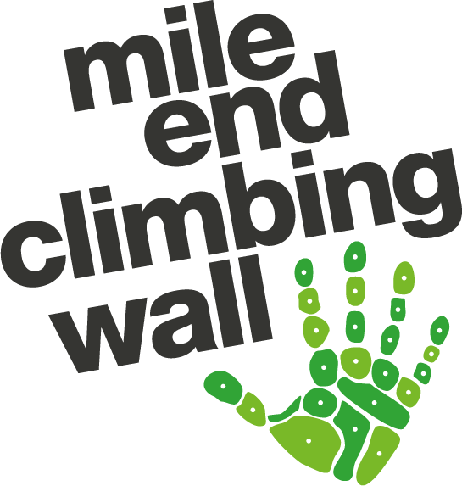

Original document created by Carlos Simon, (H&S Officer). Updates by Georgia Ferguson, Saskia Menti (H&S Officer) and Dean Straw (CEO).

CONTENTS

1: OVERVIEW
2: MANAGING CONTACT
3: MANAGING CAPACITY
4: MOVING AROUND INSIDE MECW’S FACILITIES (SOCIAL DISTANCING)
5: PROTECTING MECW’S STAFF
6: ACCIDENTS, SECURITY AND EMERGENCY PROCEDURES
7: VENTILATION
8: CLEANING
9: COURSES
10: APPENDIX

1: OVERVIEW
This document has been created following ABC and government guidelines to minimise the risk of contracting and spreading COVID-19 at Mile End Climbing Wall. Whilst it is recognised that completely removing the risk in climbing walls is impossible, we will do everything we can to keep customers and members of staff as safe as possible, while bringing back our so much loved and awaited sport; climbing.
- These are the government guidelines followed to create this document:
  - https://www.gov.uk/guidance/coronavirus-covid-19-grassroots-sports-guidance-for-the-public-and-sport-providers (accessed 03/04/2022)
- And these are the ABC support documents:
  - https://www.abcwalls.co.uk/news/coronavirus-updates-and-weekly-news/
Following these guidelines will certainly have an impact on the customer’s experience, and, whilst we recognise the potential frustration that this might cause on some climbers, we all need to do everything we can to keep the COVID-19 health crisis under control and provide the best possible environment for customers and MECW’s employees.

2: MANAGING CONTACT
Objective: To minimise contact with surfaces, employees, other customers and contractors within facilities or while participating in sport and physical activity. Primary control for minimising transmission through contact is through sufficiently frequent handwashing.
- Customers and staff will be asked to not attend the Wall if they have any of the symptoms of COVID-19, this information will be on our website and communicated to staff
- Hand sanitiser is provided at the entrance/exit in the Foyer
- Hand sanitiser stations are strategically placed around the centre
- Customers will be encouraged to wash/sanitise their hands before entering, during their visit and before leaving the premises
- Water fountains will only be used for personal bottles, no mouth to water fountains will be operational
- Rental shoes will be available but customers will be encouraged through staff communication to wash their hands before and after handling rental shoes
- Staff will spray shoes with anti-bacterial spray after use as normal
- We remain cashless to minimise contact between staff and customers through money handling

3: MANAGING CAPACITY
In line with the current situation we have removed all capacity limits relating to COVID-19 measures. With doors open and extractor fans active, air circulation will not be a problem and certainly will meet the government guideline of keeping an air flow of 20L per person per minute. This is considered very low and easily achievable with the mechanical ventilation systems we have.
- Our maximum capacity is currently 300 customers

4: MOVING AROUND THE FACILITIES (SOCIAL DISTANCING)
Objective: To ensure distancing among employees and customers when possible whilst moving around inside the facilities.
- Hand sanitiser is available on entry to the Wall
- Hand sanitiser stations are strategically placed around the centre
- Changing rooms and showers are open for use, and are cleaned extensively each evening
- Social distancing is facilitated as far as possible between customers and staff by managing the centre capacity
- Staff are reminded to socially distance as far as possible when working

5: PROTECTING MECW’S STAFF
Workplace testing:
- We will not be requiring staff to take regular LFTs, unless they have been in contact with a confirmed positive case
- If staff have been in contact with a positive case, we will ask them to take a LFT before their next shift
- There will be LFTs available at the Wall for all staff to take home and use
- In the event of a positive test result, staff should follow government guidelines and refer to the policies stated in Appendix 3 of this document
Our policy and procedures on workplace testing will be reviewed again on the 1st April 2022 following the proposed changes in government guidelines and end of free testing in England.
PPE:
- Protective screens are installed on the counter to shield the counter staff when interacting with customers
- Masks and other PPE are not mandatory but will remain available to staff should they wish to use them
- Hire shoes are sprayed with antibacterial spray as normal and rotated to allow time between users
  - Whilst there is no evidence of virus transfer through sweat, staff are advised to wash their hands immediately after this task for hygiene reasons
- Contact between staff and customers is reduced by customers placing shoes into a container and customers are encouraged to wash hands before and after handling shoes

Higher Risk Employees:
If an employee identifies as high risk with regards to covid, their individual case will be studied and addressed following the government guidelines in place at the time of beginning of their employment, as well as updating any provisions put in place as and when guidance changes.

General Staff Operations:
- Upon commencement of employment, staff will be trained on all the protocols and procedures related to minimising COVID-19 risks (they are all listed on this document)
- Any updates to these procedures will be communicated to staff via email and/or DM shift updates
- All rules applying to the public will also apply to employees both when working and not working, unless otherwise stated
- Before or after hours climbing for staff only will be allowed as long as the guidelines listed in this document are maintained, and in the presence of a manager as usual
- Shall any MECW employee have any doubt or disagree on any of these guidelines and procedures, they should contact a senior manager immediately

6: ACCIDENTS, SECURITY AND EMERGENCY PROCEDURES
Objective: To prioritise safety during incidents. In an emergency (e.g. an accident, provision of first aid, fire or break-in) people do not have to stay appropriately distanced if it would be unsafe. People involved in the provision of assistance to others should pay particular attention to sanitation measures immediately afterwards including washing hands.
- Although there may be heightened concerns around first aid, this will continue as normal
- The below adaptations will be used when needed:
  - Staff undertaking rescue at height will use suitable PPE
  - Gloves and resuscitation face masks will be provided to all first aiders for emergency first aid
  - If the first aider deems the situation too urgent they should continue with administering first aid and medical advice should be sought afterwards
  - Used PPE should be disposed of in line with government guidelines

7: VENTILATION
Ventilation is an important part of mitigating against the transmission of COVID-19. Ventilation into the building should be optimised to ensure a fresh air supply is provided to all areas of the facility and increased wherever possible. Due to the amount of air flow and space usually present in our facility, it is not a concern that lack of ventilation will be a problem at MECW.
- All extractor fans will be on during opening hours

8: CLEANING
Objective: To keep the workplace clean and reduce the risk of transmission by touching contaminated surfaces, and help everyone keep good hygiene through the working day.
- The facilities will be professionally cleaned daily after closing/before reopening the centre
- Staff and customers are reminded to wash their hands after touching regularly used surfaces and touch points
- All rental harnesses will be quarantined on rotation basis after each rental rather than being cleaned
- Hire shoes are sprayed with antibacterial spray as normal and rotated to allow time between users
- Climbing holds are cleaned within route-setting schedules as normal and are considered as part of the infrastructure of the facility, as per ABC guidelines
- During normal centre use, hand hygiene practice for customers is encouraged and facilitated to reduce risk of transmission - holds aren’t cleaned between customer usage

9: COURSES
MECW is providing its full provision of courses in line with our covid guidelines.
- Courses will be capped at a 1:6 instructor to participant ratio to facilitate social distancing where necessary
- Instructors will be provided with masks if they wish to wear them, but this will not be mandatory

10: APPENDIX
APPENDIX 1: REDUCED SERVICES
To minimise the risks of COVID-19 we have decided to limit some of the services that we usually offer. Current restrictions will be:
- No spectators

APPENDIX 2: CHALK
We believe that liquid chalk is an appropriate back-up to practicing good hygiene and sanitising hands but we currently don’t recommend it as a replacement.
- Customers will be able to purchase liquid and regular chalk at the Rock On shop, as usual

APPENDIX 3: IF COVID-19 CASE IN STAFF
Staff should inform us of a positive result as soon as possible, whether they are asymptomatic or not. Knowingly providing false information or withholding information could lead to disciplinary action. Staff should stay at home until they receive a negative LFT result.
- If a staff member tests positive for COVID-19 and is feeling unwell, the parameters set in our Absence Policy apply
- If a staff member tests positive for COVID-19 and is not experiencing any symptoms, we might opt to cancel their shift in order to protect their colleagues and our customers
  - If you are working under a zero-hour contract or your upcoming shifts are overtime and the company chooses to cancel your shift(s) following a positive result, you will be paid in full for your scheduled shifts for the next 7 days, in line with the Absence Policy
  - Past the 7-day mark and dependant on whether or not you are still testing positive, the company may opt to cancel your shifts without remuneration
  - If you are salaried or on a guaranteed hours/days contract, the parameters set in our Absence Policy apply

APPENDIX 4: IF COVID-19 CASE IN CUSTOMER
MECW will follow the PHE Guidance – ‘COVID-19 – Cleaning in non-healthcare settings’ while cleaning all areas of the facility.

